The Power of Drought

Mapping Drought Impact in California and Determining Responses and Future Preparation for Drought Patterns and Theirs Effects

Edward Rao  
 IGME 770  
 Rochester Institute of Technology  
 Rochester NY USA  
 er9427@rit.edu

ABSTRACT

When it comes to the realm of natural disasters, it is difficult to claim that any sort of disaster could be any “less” devastating than others, and yet when compared to hurricanes, tsunamis, or earthquakes, droughts rarely make headline news, and as a result the effects that they cause can often times be overlooked. In this project proposal, we will be focusing on the impact of the lack of rainfall in three areas of Southern California and use data of flash flooding, fires, human expenses, and population concentrations to determine their long-term effects and the best ways to protect the ecosystem, prevent property losses, and potentially save lives.

PROBLEM DOMAIN

A drought is defined in the Merriam-Webster dictionary as “a period of dryness especially when prolonged” [1], and provides insight on perhaps why they tend to be overlooked when it comes to natural disasters. The drought that plagued the state of California from 2011 to 2017 did not truly attract any media coverage or widespread attention until early 2016, with the Bay Area and more inland counties hit particularly hard [2]. While it is true that this is partially because droughts are not as destructive or damaging to areas affected by it as other terrible disasters such as hurricanes, tornados, or tsunamis, there is a high probability that because of the nature of droughts, any potential damages and costs are not as obviously destructive as the damaged property and deaths left in the wake of other disasters.

In truth, droughts, along with the subsequent changes in weather and climate they cause, can lead to ecological and humanitarian crises that are just as if not more devastating than the fallout of other natural disasters if not addressed. Patterns in droughts over the world have revealed that long, sustained periods of drought is not only devastating to humans in economic and sustainability terms, but also to the environment, wildlife, and surrounding areas that can quickly snowball into repercussions able to be felt across the globe [3].

California has had issues over the past few decades with its climate and unique geography that have both contributed to the particular vulnerability of drought in the state, with extensive periods of drought and lack of proper response leading to its already prevalent low rainfall and wildfires that have been exacerbated by the ever-increasing number of droughts and climate change that are affecting the state to this very day [4].

OBJECTIVES

Our main objective is twofold. First, we obviously must create useful and accurate visualizations that provide a means of assessing the impact a lack of rainfall has on the water levels, human costs, and environmental changes of the focus areas that will be observed. This means representing in a reasonable fashion the effects of droughts and drought-like weather conditions have on the area and its inhabitants, which can come in the form of charts, diagrams, and above all else maps and visualizations created in ArcGIS.

Second, with the deliverables that are procured, we must find a way for the data acquired in this project to be easily analyzed and extended upon; that is, it should be very easy for future studies and extended topics of work to come from this project, and this is essential in possibly devising methods to limiting and containing the damages that drought can inflict in the future. There should also be some discussion and proposed solutions derived from what the data gathered, and setting up hypotheses or questions future projects can tackle head-on.

LITERATURE REVIEW

Four peer-reviewed academic articles are used as a basis of existing work to build the foundations for this project and provide inspiration and guidance as to the direction of potential venues of work. The first is a spatial assessment of drought risk in the country of Bangladesh [5] that is exacerbated by its geography and rainfall levels in many regions of the country. The article lays out drought risks via the precipitation index data and compiles it in GIS, providing a visual representation of drought and emphasizes a combined role of hazard and vulnerability when analyzing risk. It also takes into account the social and physical factors for drought vulnerability and why Bangladesh, known for its already-high level of poverty compared to its neighboring countries, is hit particularly hard.

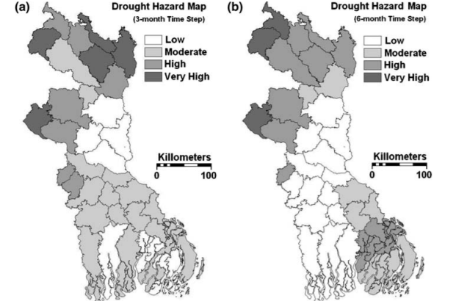

Figure 1: Bangladesh Drought Hazard over 1 and 6 months

The article on regional landslides by He [6] analyzes the landslides that are caused by weather changes or population movement, particularly those caused by rainfall after long dry spells, which often leads to sinkholes or mudslides due to the loose, dry soil. A case study is conducted in SoCal using a GIS statistical approach in mapping susceptibility via seismic landslide scars from historical data, and seven different potential risk factors are selected from the data and mapped to a new, more informative map.

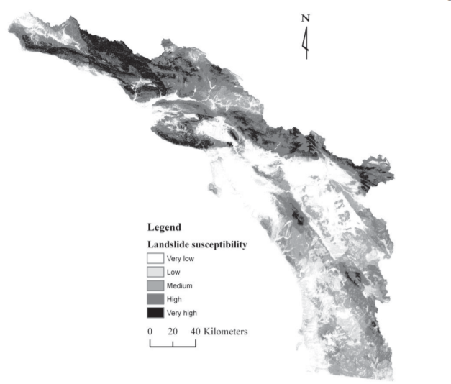

Figure 2: Landslide Susceptibility in Southern California

For water purity and rain runoff, Lee’s article [7] takes a look at the drinking water reserves and how nutrients in the sediment in the water can affect its quality, particularly after a rough dry spell. The case study in South Korea explores Chuncheon Dam and analyzes phosphorous levels in stored drinking water, and how a drought can compromise even the most securely-stored volumes of drinking water. And finally, the GIS remote sensing and drought monitoring article by Thenkaball [8] is somewhat less relevant, but provides a good deal of insight on drought monitoring, information on California and its history of drought, and soil moisture.

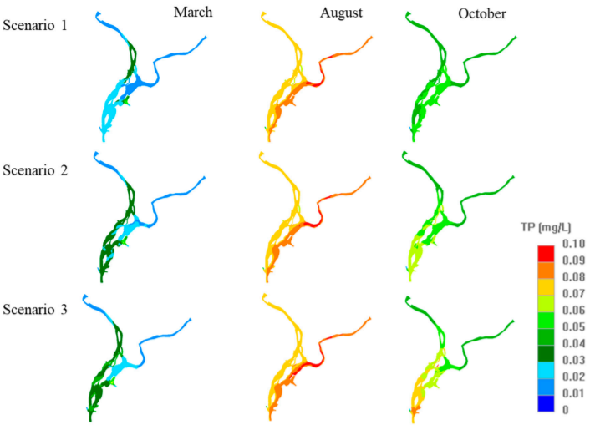

Figure 3: Drought patterns and Average Rainfall in California (and Nevada)

METHODOLOGY

For this project the primary means of execution will be the usage of ArcGIS and map data. The datasets that will be used (listed in the following section in detail) will be integrated and combined into the base GIS map of California, with the necessary cleaning, truncating, and integrating necessary in order to begin forming the map and data we will be using. Through ArcGIS, vector models of climate changes and spatial analysis methods ala variation and diversity. Focus will be placed in particular on areas of Monterey Bay off the coast of the Pacific, Joshua Tree National Park, and the city of Los Angeles and the surrounding county (the city of Bakersfield will also be outlined just for comparison purposes).

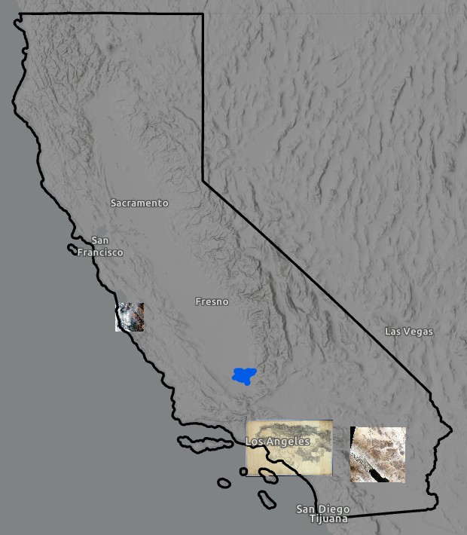

Figure 4: Drought patterns and Average Rainfall in California (and Nevada)

On the same map will be included the analysis of climate, terrain, and reserves for local wildlife, with a focus on wild deer reserves and how the areas overlap with drought areas, which can lead to disruptions in animal migration patterns and living patterns of the local population. From the gathered data more difficult-to-represent parts of the gathered data will also be represented in separate diagrams and tables to show more visually trends and patterns involved. For human impact, the primary concern is one of safety and security before other factors such as material loss or forced migration, but these factors must all be taken into account as none of these individual components are truly independent.

The time period of these datasets will be set in the past 36 months. Despite relying on historical evidence for context, the extensive scope of droughts, particularly the one from 2011 to 2017, as too lengthy a period to analyze with the tools in our class, as all of our variables would have to be over that same amount of time, likely more. This runs the risk of not just difficulties with the tool and handling so much data, but also leaves the data susceptible to the influence of outliers and errors without heavily skewing the rest of the data and leading to very obvious blips on the map itself, leading to a terribly wrong view and understanding of the causes and effects of a serious issue.

DATASETS

The datasets used in this assessment consist of a base California map and the location the waterways, along with the geographic imagery and terrain that comes with the integrated ArcGIS Pro satellite view of the map. Two of the most important datasets would be the primarily populated areas and precipitation levels, both of which would be integrated directly to the map.

Subsequent datasets involved are the average temperature over the 36 months in order to serve as both cause and effect of flooding, as well as (in places where they are important) waterways such as pipelines, artificial “rivers”, and runoff paths for rainwater into reservoirs or the ocean. These datasets are largely compatible with the map due to the presence of shapefiles, which add themselves into the table and do not require any extra work to incorporate with the base map or other layers, although layering and ordering does need to be kept in mind when thinking about visibility.

For the effects of drought, initial plans were to calculate water prices for residential areas and analyze the effects of the impact of drought and how it would be affected by the drought, but in the process of implementation the difficulty of classifying it was inconducive to the many various factors that water bills could result from, along with the difficulties in obtaining a mean or median value over time for water bill rates, and the lack of appropriate data. This led to the replacement of the factor by a simpler, albeit less telling, variable in the median household income, which could provide information about the area drought has stricken and be more helpful when analyzing and synthesizing the data and drawing conclusions.

Besides the above data, two other datasets were included, involving the areas of deer and critter habitats as well as the locations of individual health facilities, whether in the form of hospitals, pharmacies, or other medical service areas. While drought is usually not associated with the need for medical centers (heatstroke, hay fever, and related obvious symptoms aside), the hidden long-term effects created as a result include dryness and incidents like flash floods or forest fires can quickly devastate a large amount of the population in an incredibly small period of time. In these cases, the location of health centers is crucial.

Finally, highly concentrated population centers (aka cities or towns) are included, with the housing income dataset joined to these populated areas via the “name” column shared by the two. These are useful in many areas of California, but in the three areas of focus, it’s much more essential for understanding rapid response, particularly with the different geographical and human elements that constitute each of the regions.

The many layers included will not all be enabled all at once for map clarity and to prevent cluttering and oversaturation. Instead, individual datasets and map layers will be presented in conjunction with the aspects that they are most similar with or have a direct connection with. Labels provided will only be in reference to location and not as a substitute for results.

RESULTS

With all the datasets gathered, the overall map displays the various factors and layers that all play a role in understanding drought’s adverse effects. An overall quick glance of the map reveals that the coastal areas of the state, particularly the more populated, also tend to suffer more from drought. Because of the geography of the state of California, however, the Sierra Nevada mountains in the east seem to form a sort of “buffer” zone of drought that is sandwiched between the slopes of the mountains and the coastline (Figure 5).

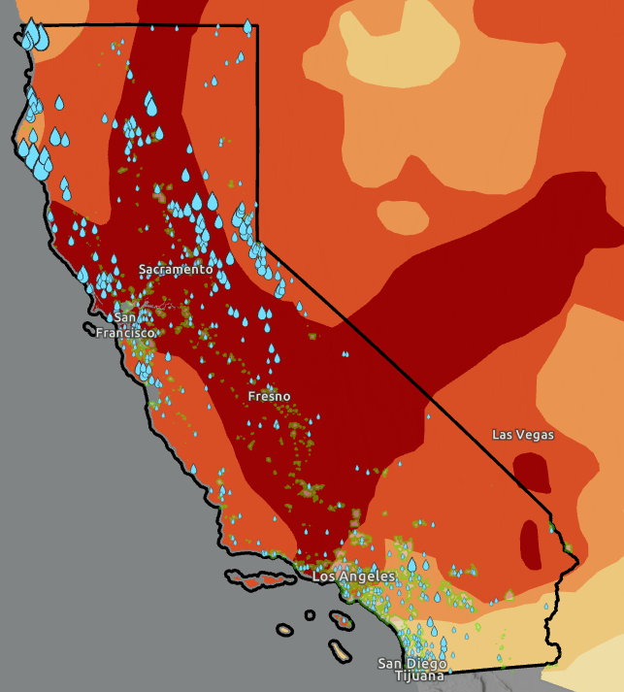

Figure 5: Drought patterns and Average Rainfall in California (and Nevada)

Figure 5 also includes areas of significant (not random) rainfall in the form of droplets, with greater size equating to higher levels of rainfall. While there seems to be a pattern between rain levels and drought, there are also other unexplained factors that will be subsequently addressed.

For the distinct focus areas, each encapsulates a particular terrain that corresponds to the area, with coastal, city, and desert areas included with a good deal of range. The contrasts will be seen as when taking a look at the coastal areas near Monterey Bay, a populated area, and the mountains of the Robles del Rio, which is significantly less populated, but contains a history of high temperatures and fires (Figure 6). These areas are indicated by the heat map red circles, while waterways run through the mountains it is in fact the more populated city of Monterey that is hit with fires. Of note is a large, noticeable waterway in the eastern part of the map that is not available directly to the city due to its coastal vicinity, which also suggests that the fires can be affected and exacerbated by drought-impacted locations.

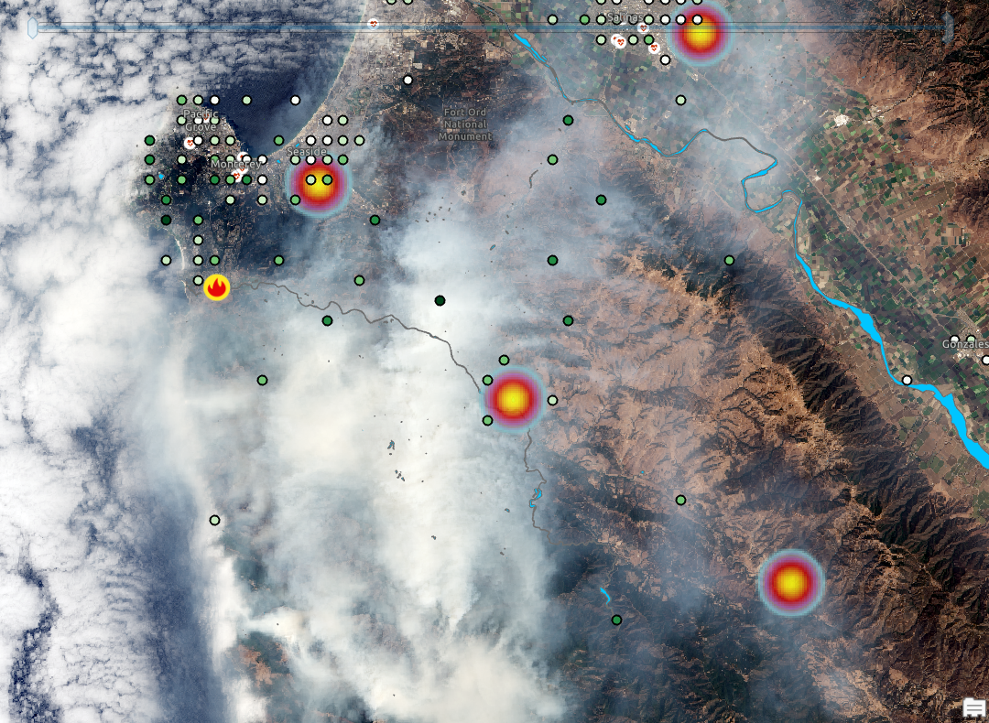

Figure 6: Drought and Populations in Monterey Bay (upper left) and surrounding area

In Figure 6, highly concentrated population areas are supplemented by the green dots of various level that indicate 5 normally distributed groups of median household income. The mountains contain sparsely populated populations of fewer, overall richer people while the city contains a mixture of individuals of all levels of income.

Taking a look at the natural park reserves (Figure 7), a better explanation of the lack of fires could be due to the presence of park enforcers and firefighters, with a more regulated ecosystem as compared to the city. However, fires can still break out despite preparation, as shown by the one on the edge of the park border and Monterey city itself.

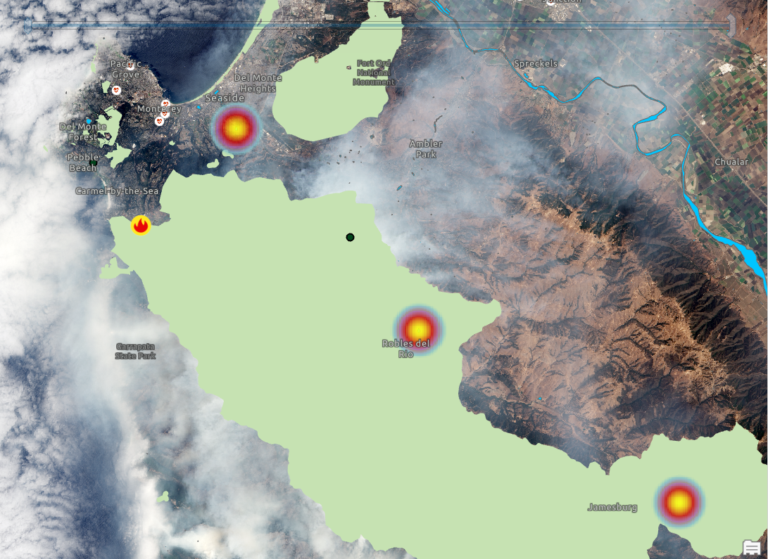

Figure 7: Temperature and Fires in habitats around Monterey Bay

And while it appears that the effects of drought in a coastal area such as this does not seem to be too severe, it is also a less densely populated area, with little forestation and a receives more rainfall comparatively to other areas of the state (Figure 5). There are also no landslides or flash floods or post-drought rains, although this may simply be a result of the more normal temperatures in the past 36 months.

The city of Los Angeles, meanwhile, lies within the range of drought and rends to have extremely high temperatures in the summer months. In Figure 8, areas with high heat and fires, alongside households with “high” (<10%) incomes are pictured.

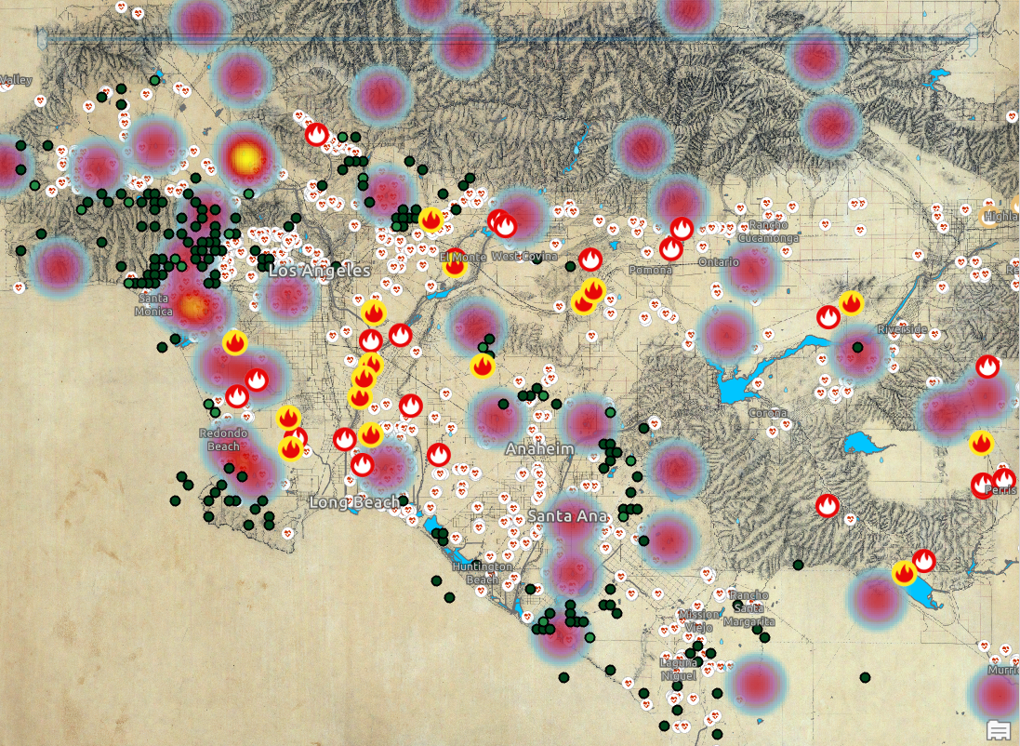

Figure 8: LA fires and wealthy neighborhoods, with temperature and water reservoirs and pipelines

While Los Angeles is know for being a haven for celebrities and movie stars (like Beverly Hills, pictured in upper left of Figure 8, or Hollywood), this contrasts with the lower end of the income spectrum, with Figure 9 showing the contrasting same area for locations of poor communities.

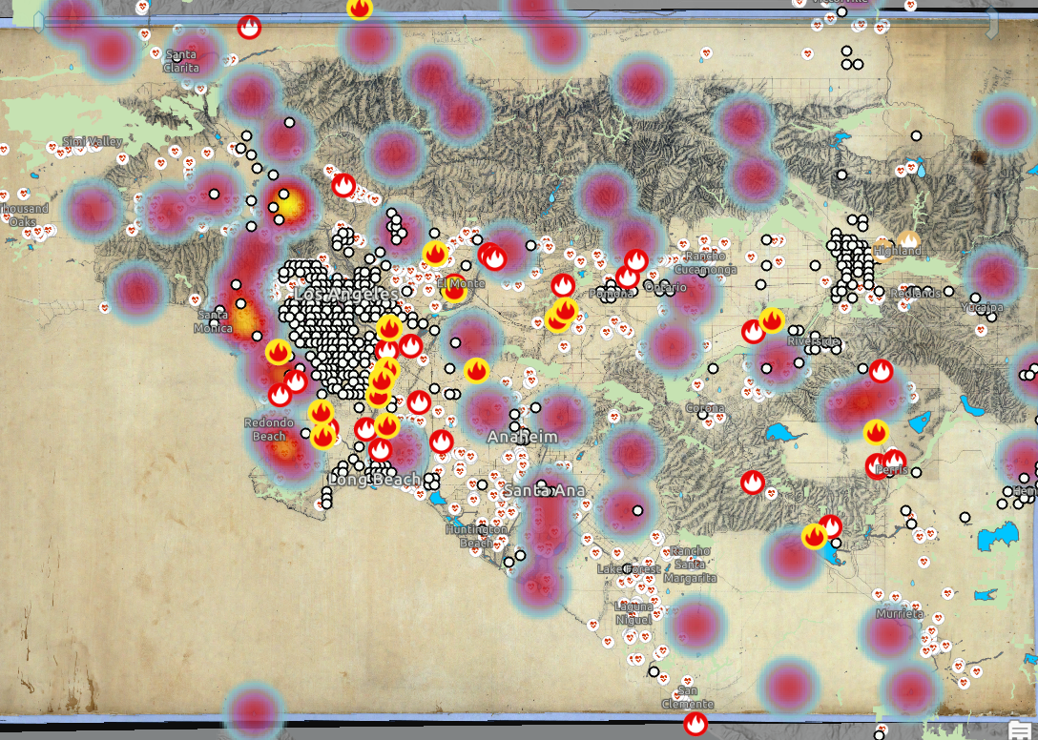

Figure 9: LA fires and low-income households, with temperature and water reservoirs and pipelines

With Los Angeles one of the largest cities in the world, the discrepancy for “household income” for specific areas can be seen. Fire damages seem to lie within the city and are concentrated around poorer areas.

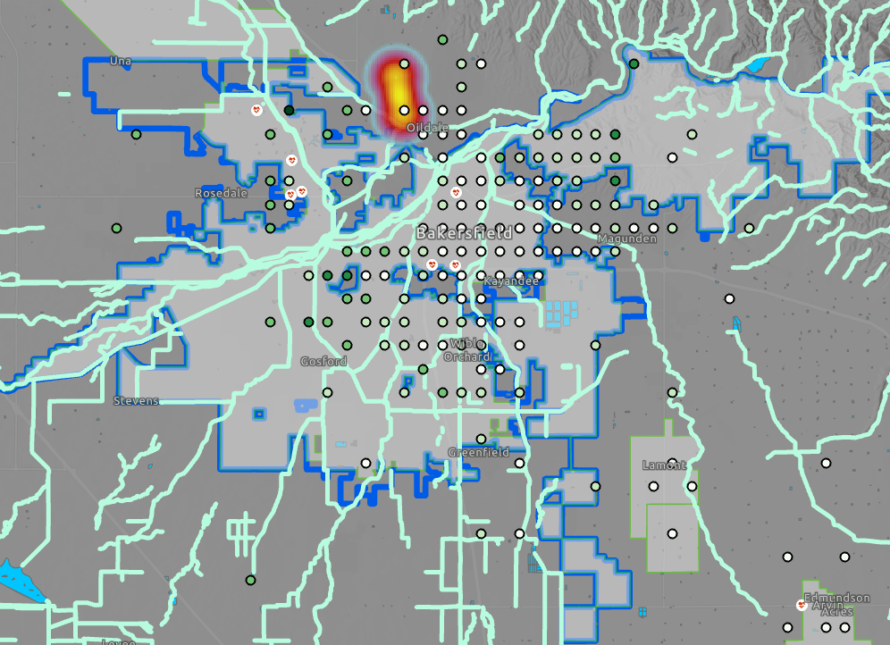

Figure 10: Boundaries of Bakersfield, along with health centers and water reserves

In contrast to LA, Bakersfield (Figure 10), while widely recorded as one of California’s hottest areas [9], is far less susceptible, with not a single instance of drought-related fire or geographic incident in conjunction. Despite its more inland location right in the middle of the drought zone, Bakersfield is relatively safe. Whether this is due to the city’s familiarity with drought conditions and advanced planning, or simply an issue with the time period the data is selected from, is up in the air.

Further to the south, in Riverside County, Joshua Tree National Park sits as a more “benign” and human-friendly version of Death Valley National Park. Despite its arid climate, the park contains an extensive water and irrigation system, and its temperature, while much higher than the surrounding city, where fires are more frequent (Figure 11). And while there are mountains in the area, the dry soil and lack of repeating hills and valleys generally creates a basin with much safer terrain than expected.

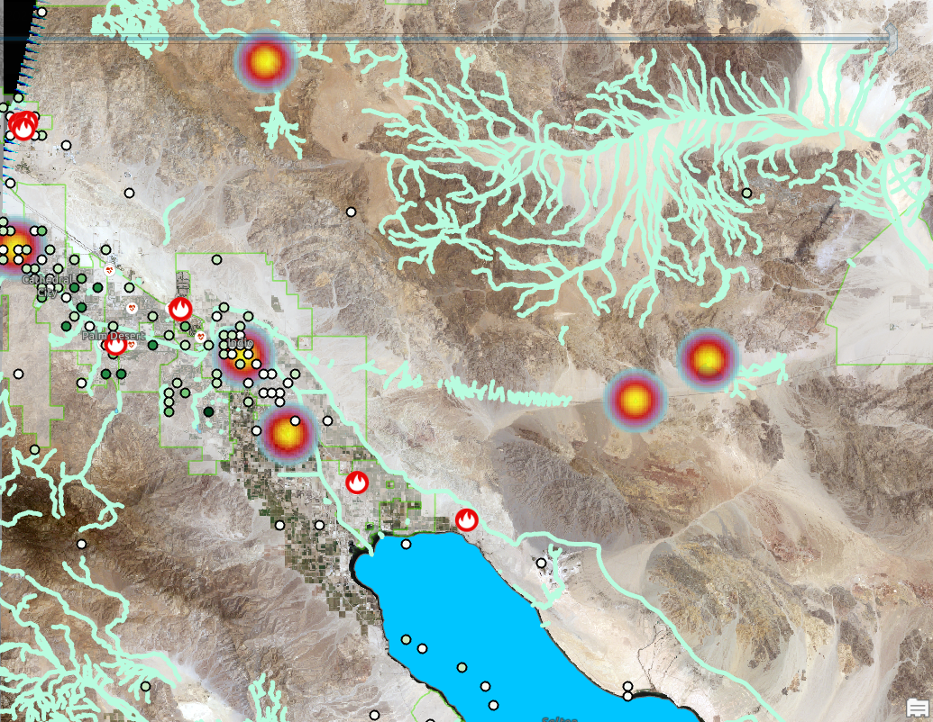

Figure 11: Joshua Tree National Park and surrounding county of Riverside

CONCLUSIONS

Overall, the results seem to speak for themselves, as geography and water pipeline infrastructure have shown themselves to be the primary motivators for areas of drought. This, however, does not prevent the areas WITH drought as being the only areas AFFECTED by drought. The presence of water storage and terrain does not necessarily mean there are fewer drought-related damages, and rainfall/temperature itself is not enough to determine whether a fire or landslide will break out. In fact, population and topology seem to be far larger contributors to drought effects than what we previously believed in the hypothesis.

With the results obtained, it’s safe to say that while drought is not an overlooked area of focus, particularly in an impacted state like California, it’s still important to focus on preventing potential dangers that long-term droughts can cause, and based on the results obtained, it’s perhaps even more essential to focus on areas with higher populations, human or otherwise, that tend to result in dangerous fires or damages to property. The importance seems to lie in building good infrastructure with a prepared mindset and readiness to act in the case of disaster.

FUTURE WORK

One of the most promising directions that this topic can be taken is how to prevent loss in a natural disaster. Of course, loss in a drought is much different from loss in a more devastating disaster like a flood or hurricane, but there are many factors that can be unseen and lead to damages that are less destructive in nature. As a result, the data that we’ve found and the patterns observed can be a starting point in investigating measures that can be taken in response to these drought patterns.

Because drought can be defined differently in context for different regions based on the availability of clean, usable water, rainfall, weather patterns, and a combination of other climate and geographic factors, perhaps it would be better for future projects to define drought more specifically over a longer period of time, given it had the time and resources available that lie outside of the scope of this project.

Of course, we must keep in mind that even with the most reliable and sourced data with the most detailed and trusted metadata, there is always the chance of human error or incorrect data analysis in the information used in the project. A confirmation via new data or combining different aspects of data could be useful in the future if new developments arise that contradict our findings. Obviously, this is true for any project, but in the case of droughts that can span years or even decades, it is of even more importance due to the longer interval of time that must be accounted for.

Finally, like the Bangladesh article by Shahid, context must be taken into account. Because of California’s size and diverse ecosystem, different areas of the state will naturally have a different level of preparedness and response to drought, earthquake, or other natural disasters in the area. We must take into account social, geographical, and even political factors in order to develop a full comprehension of the power of drought.

REFERENCESE

Conference Name:ACM Woodstock conference

[1] <https://www.merriam-webster.com/dictionary/drought>

[2]<https://www.drought.gov/states/california#historical-conditions>

[3] Adams, H. D., Luce, C. H., Breshears, D. D., Allen, C. D., Weiler, M., Hale, V. C., ... & Huxman, T. E. (2012). Ecohydrological consequences of drought‐and infestation‐triggered tree die‐off: insights and hypotheses. *Ecohydrology*, *5*(2), 145-159.

[4] <https://yaleclimateconnections.org/2021/06/california-americas-garden-is-drying-out/>

[5] Shahid Shamsuddin, Behrawan H. Drought Risk Assessments in the Western Part of Bangladesh. Published online: 28 February 2008 Springer Science+Business Media B.V. 2008

[6] He Yiping, Beighley RE. GIS-based regional landslide susceptibility mapping: a case study in southern California. Earth Surf. Process. Landforms 33, 380–393 (2008) Published online in 8 August 2007 Wiley InterScience (www.interscience.wiley.com) DOI: 10.1002/esp.1562

[7] Lee HW, Lee YS, Kim J, Lim KJ, Choi JH. Contribution of Internal Nutrients Loading on the Water Quality of a Reservoir. Water. 2019; 11(7):1409. https://doi.org/10.3390/w11071409

[8] Zachary Asbury, Mohamed H. Aly. (2019) [A geospatial study of the drought impact on surface water reservoirs: study cases from Texas, USA](https://www.tandfonline.com/doi/abs/10.1080/15481603.2019.1582154). GIScience & Remote Sensing 56:6, pages 894-910.

[9] https://weatherspark.com/y/1451/Average-Weather-in-Bakersfield-California-United-States-Year-Round

Conference Short Name:WOODSTOCK’18

Conference Location:El Paso, Texas USA

ISBN:978-1-4503-0000-0/18/06

Year:2018

Date:June

Copyright Year:2018

Copyright Statement:rightsretained

DOI:10.1145/1234567890

RRH: F. Surname et al.

Price:$15.00